1. import this project as maven.

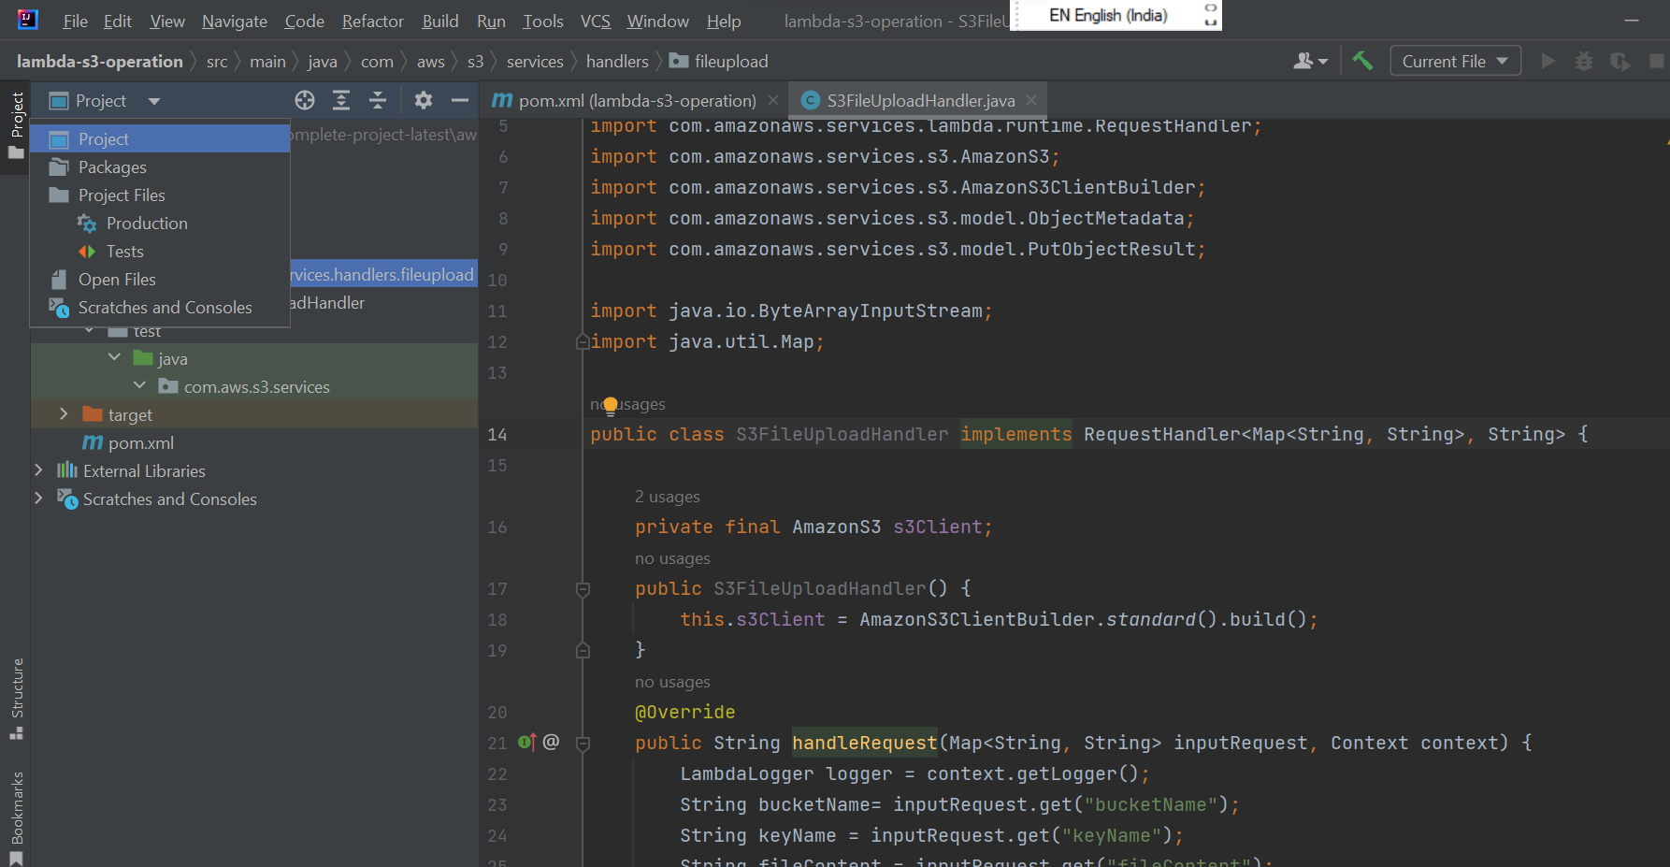

1. go to terminal and run below cmd.

mvn clean package

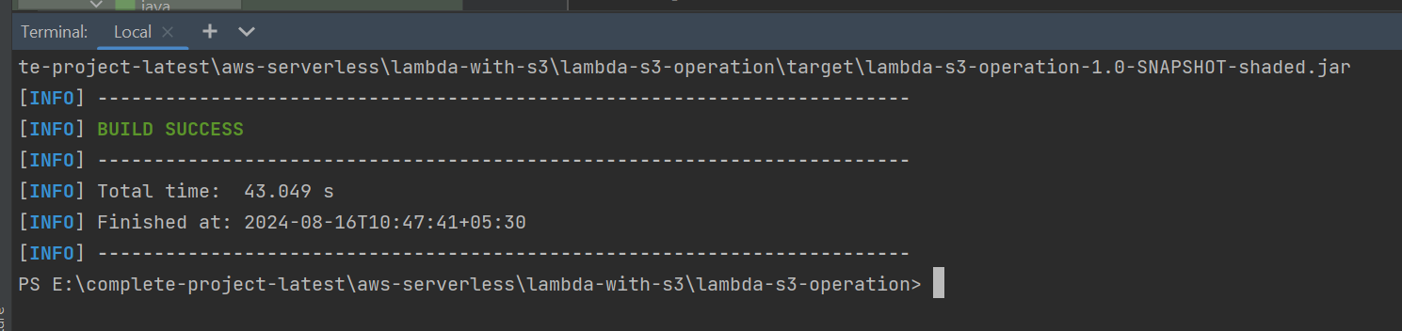

1. go to aws console and create lambda function.

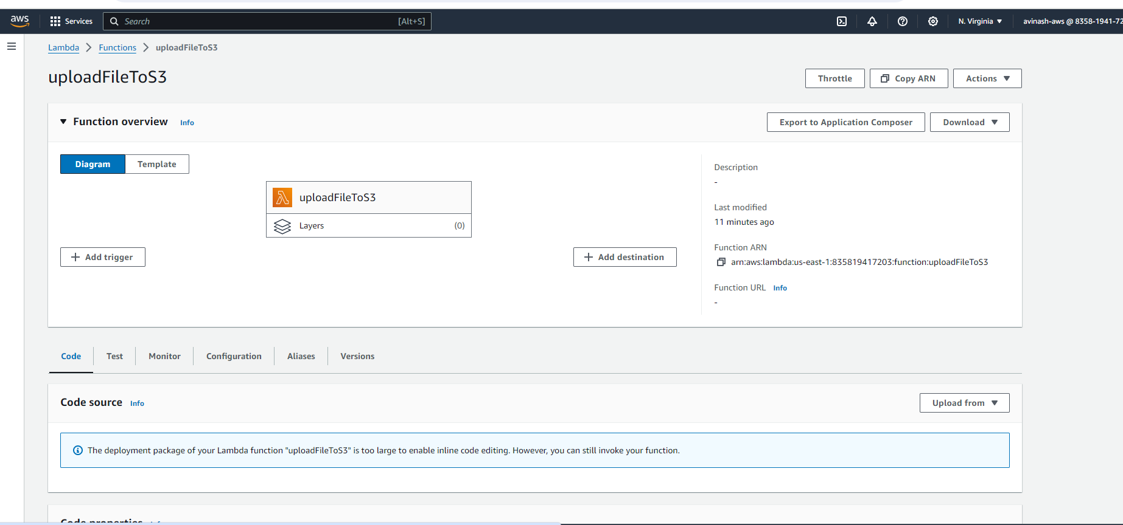

Add s3 permission to lambda.

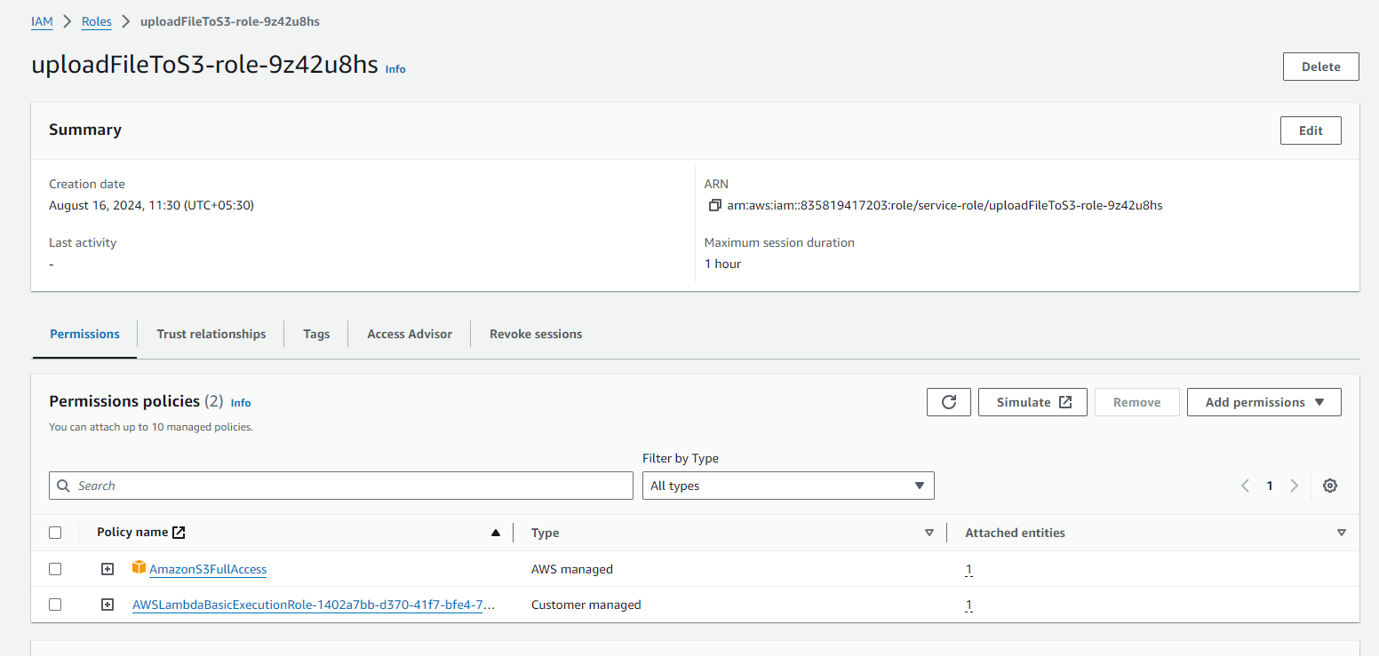

Now configure your handler by clicking on edit button.

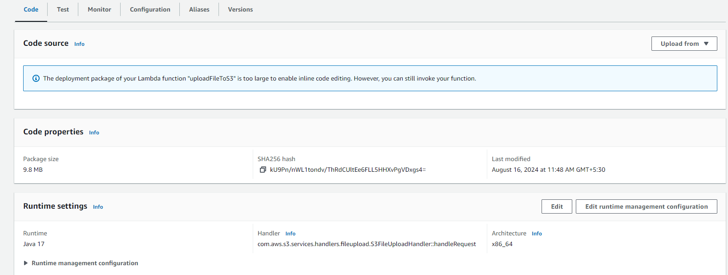

Go to Test tab and configure API Gateway and send below request to test it from console.

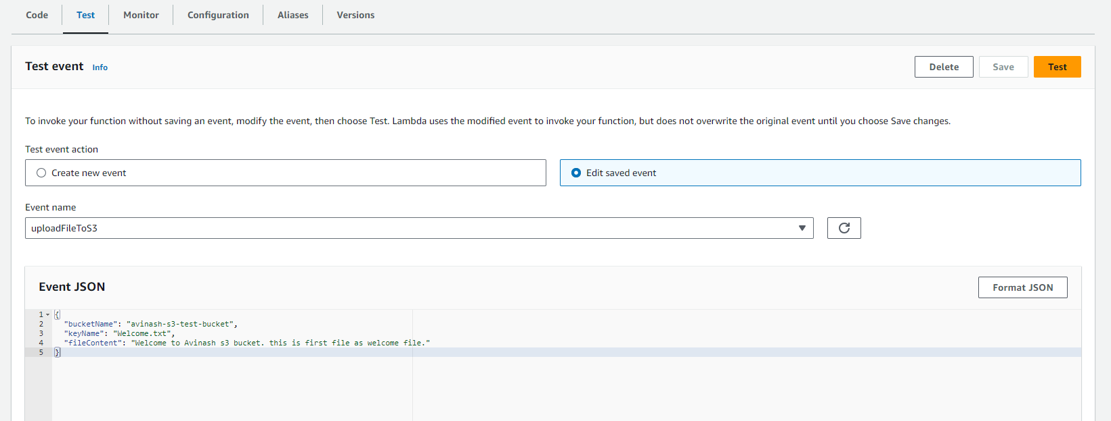

After success execution it will upload file to s3 as shown.

